**INSTRUCTION**

First you have to set database directory path. You should have both databases in same directory. For that you have to change in **frmLogin.vb** code like shown below on line no. 6:

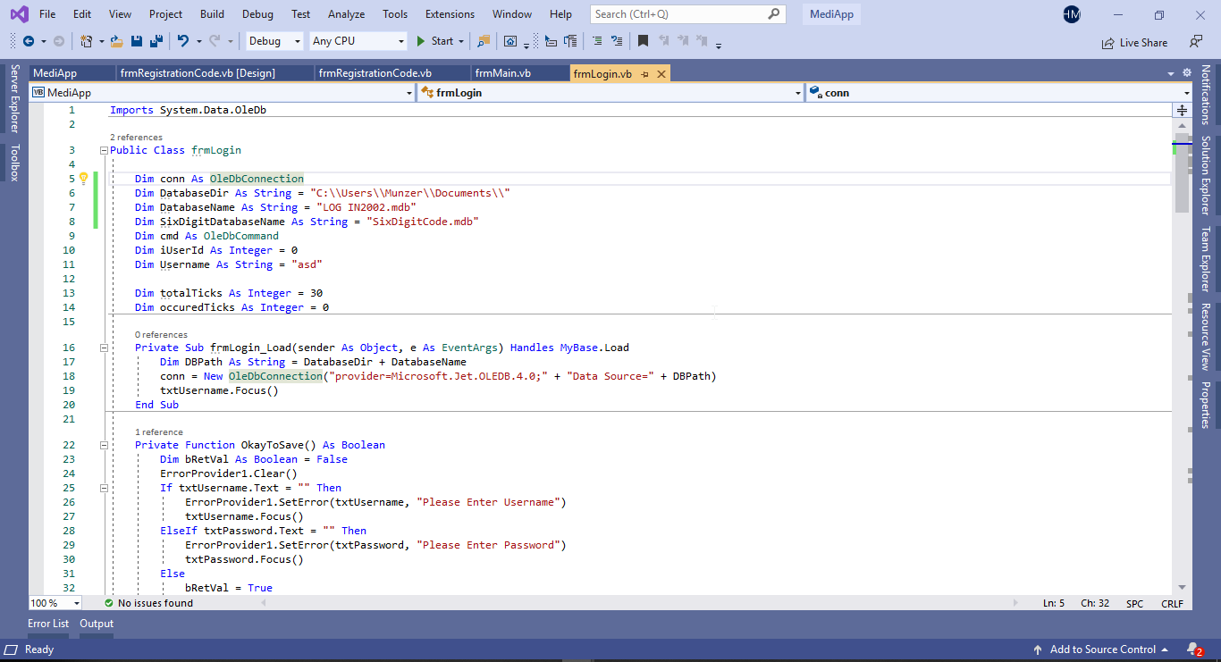

**Drawn Imagery of expected Graphical User Interface**

**Welcomed by splash screen:**

**Two parts of the registration process:**

**PART1**

**2**

**LOGIN:**

Main Form:**

**Explained Screen captures for the design element of the Program ( with beta testings included) & Technical solutions & Evaluation**

**Login Screen:**

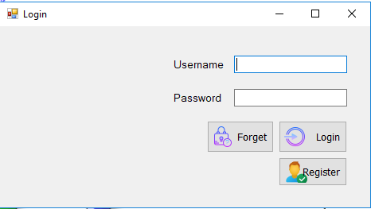

The LogIn form where existing users can login using their username and password. The Forget button is for those who’d like to reset their password if they’ve forgotten it and the process that carries out in the forget password part is described later on at the registration section. New users can press Register button and a Registration Code Window will be shown:

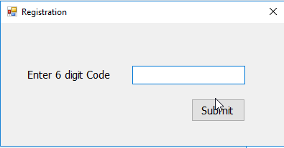

If you enter the valid code by your GP, then Registration form will open will all required fields. However the code can only be used once and is invalid after it has been used as it is unique to each patients. This also acts as a security measure as it prevents outside users from creating fake accounts and the code can only be known by a patient who has been to the GP him/herself and got the code to register.

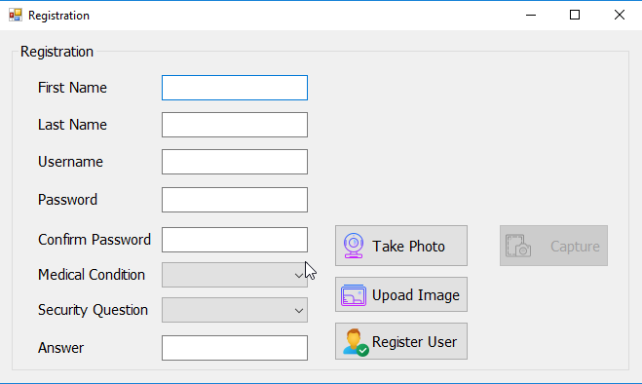

This is where user can take webcam picture by clicking on Take Photo Button and the Capture it or upload an image through Upload Image button. And Register by filling in all required details and by clicking on Register User button.

The security question is a security measure where users can go and answer their answer to their chosen security in order to reset their password if forgotten.

After registering successfully, you will come back to login screen and by provide valid credentials you can login by clicking on Login button.

**Main Form:**

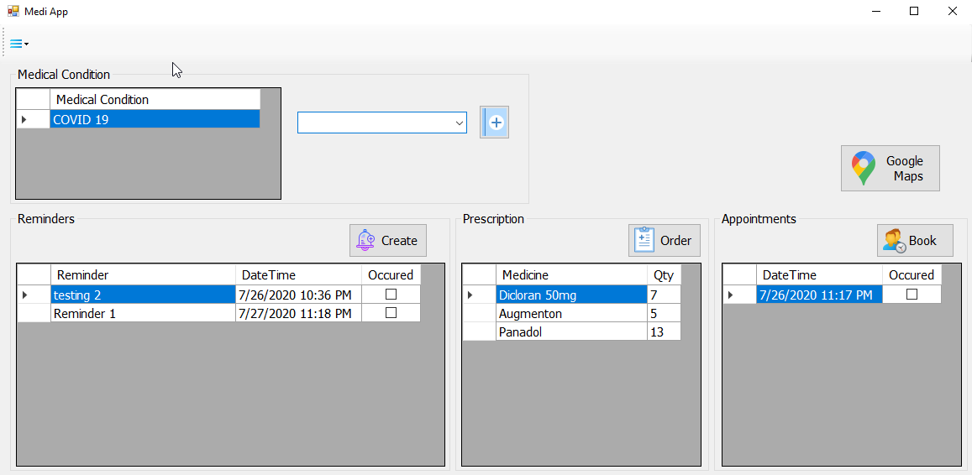

The main form of the program where users have access to all the features a patient would need. Medication reminder alert System where dates and times can be set to take medication. Prescriptions can be ordered by typing the name of the medicine and the quantity. Appointments can be booked by choosing the times and dates and even a google maps feature to help navigate nearby pharmacies and hospitals.

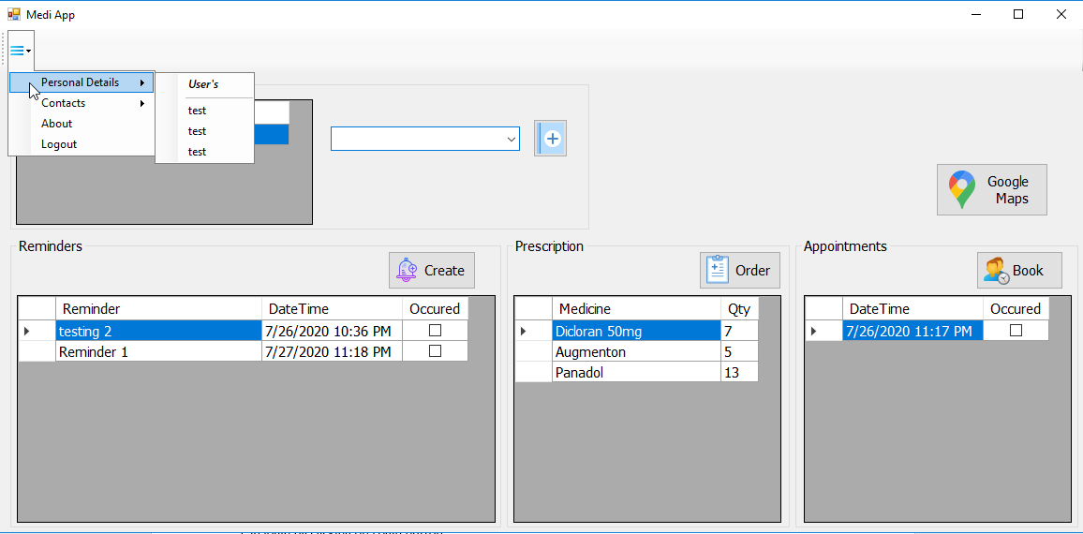

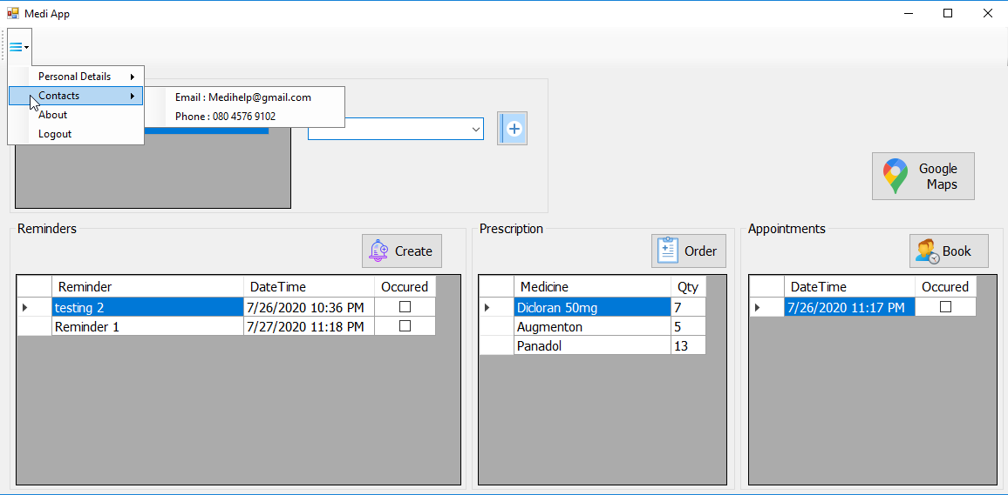A very app like three bar menu containing the User’s personal Details, ( “test” is the value used for **Beta** testing here) Contact information of the administration team of MediApp with a 24 hour mobile helpline and email service! The menu also includes background details about the Application on why it was made and what legal rights the MediApp has over its users and what we do with users information and many more. The menu bar also includes a typical Logout feature in the corner for users to log off of their accounts.

You can add new medical condition by selecting a few given medical conditions or typing it up and clicking the respective add button like shown below:

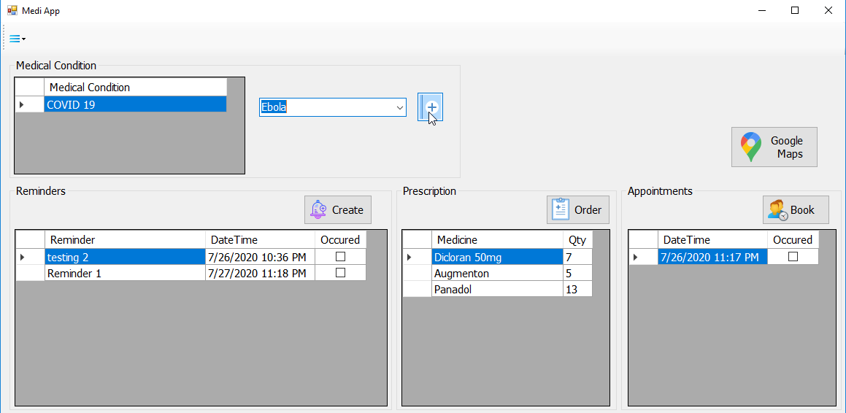

You can add reminder by clicking Create button. Bear in mind, once you’ve ticked Occurred button, the program keeps track of how much medicine you have left by deducting the stock after you have purchased an amount/quantity. So, you will be notified to order more once you’re at the verge of having an empty stock.

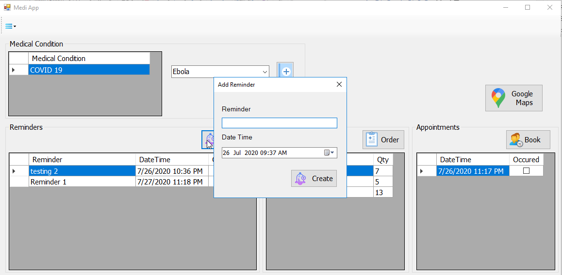

Then you can add reminder text, date and time and press click on Create.

You can order prescription by clicking order button

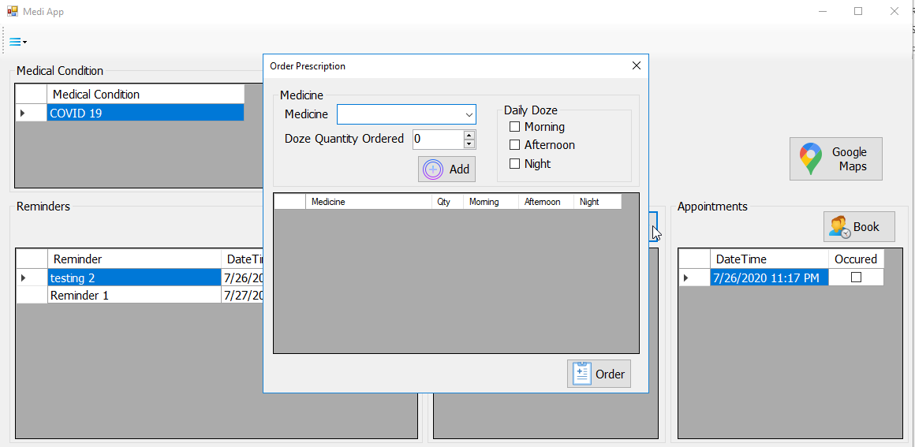

You can add multiple medicine at a time by clicking on ADD button e.g.

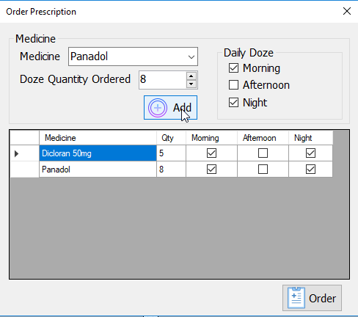

When you add all required medicines then click on order button to place an order.

You can book an appointment by clicking on book button which also includes an email feature asking if you’d like to receive an email for a stronger confirmation of the booking so that users can either check their email or the app when their booking is :

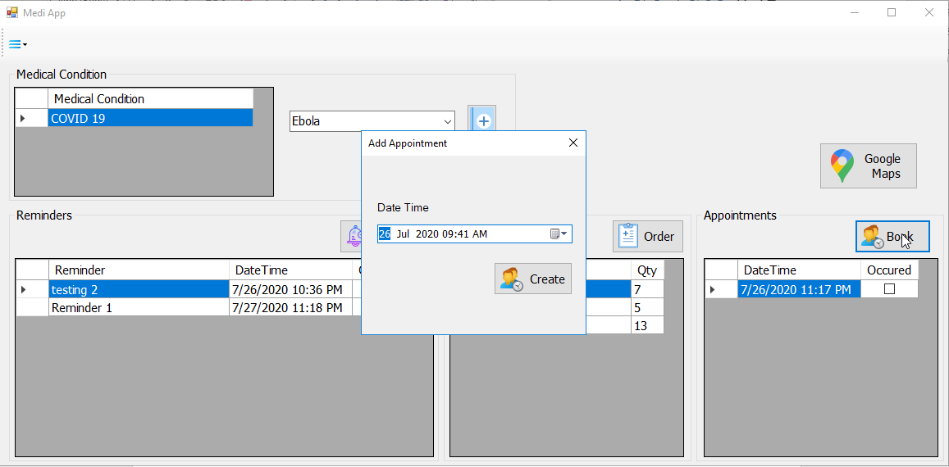

You can see nearby pharmacies and hospitals by clicking on Google Map button

Then click on search button again to will move to that page.

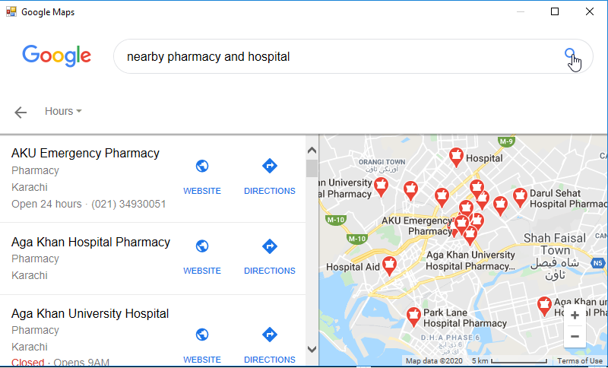

**SOURCE CODE FOR THE MAIN FEATURES WITH GREEN COMMANDS/COMMENTS EXPLAINING THE PARTS OF THE PROGRAM**

**SOURCE CODE FOR THE SPLASHSCREEN :**

|  |  |
| --- | --- |
| 1  2  3  4  5  6  7  8  9  10  11 | Public NotInheritable Class SplashScreen1  'This form can easily be set as the splash screen for the application by going to the "Application" tab  ' of the Project Designer ("Properties" under the "Project" menu).  Private Sub SplashScreen1_Load(ByVal sender As Object, ByVal e As System.EventArgs) Handles Me.Load  End Sub |

**SOURCE CODE FOR THE LOGINFORM :**

Imports System.Data.OleDb

Public Class frmLogin

'Database Directory Path

Dim DatabaseDir As String = "D:\\MediApp Program\\MediApp\\"

'Database Name

Dim DatabaseName As String = "LOG IN2002.mdb"

'Digit code Database Name

Dim SixDigitDatabaseName As String = "SixDigitCode.mdb"

'Local Variables

Dim conn As OleDbConnection

Dim cmd As OleDbCommand

Dim iUserId As Integer = 0

Dim Username As String = "asd"

Dim totalTicks As Integer = 30

Dim occuredTicks As Integer = 0

'Call when the forms Load

Private Sub frmLogin_Load(sender As Object, e As EventArgs) Handles MyBase.Load

'Combine the database directory and database name to make full path

Dim DBPath As String = DatabaseDir + DatabaseName

'Initialize access database connection

conn = New OleDbConnection("provider=Microsoft.Jet.OLEDB.4.0;" + "Data Source=" + DBPath)

'focus the username textfield

txtUsername.Focus()

End Sub

'Error handling before Logging in

Private Function OkayToSave() As Boolean

Dim bRetVal As Boolean = False

ErrorProvider1.Clear()

'if username field is empty then show error

If txtUsername.Text = "" Then

ErrorProvider1.SetError(txtUsername, "Please Enter Username")

txtUsername.Focus()

'if password field is empty then show error

ElseIf txtPassword.Text = "" Then

ErrorProvider1.SetError(txtPassword, "Please Enter Password")

txtPassword.Focus()

Else

bRetVal = True

End If

Return bRetVal

End Function

'Log in after matching credentials from database

Private Function LoginUser() As Boolean

Dim bRetVal As Boolean = False

Try

'open the connection

conn.Open()

'Initialize the command with query of any user with same username and password

cmd = New OleDbCommand("select ID, FirstName, LastName, Image from Users where UserName = '" + txtUsername.Text + "' and Password = '" + txtPassword.Text + "'", conn)

'Excute the query and load data in reader

Dim dr As OleDbDataReader = cmd.ExecuteReader

'If data is in reader then return true

If dr.Read Then

bRetVal = True

iUserId = Convert.ToInt32(dr.Item(0))

End If

'Close data reader

dr.Close()

Catch ex As Exception

Finally

'Close the connection

conn.Close()

End Try

Return bRetVal

End Function

'Clear all text fields

Private Sub ClearFields()

txtUsername.Text = ""

txtPassword.Text = ""

End Sub

Dim timestried As String = 0

Private Sub btnLogin_Click(sender As Object, e As EventArgs) Handles btnLogin.Click

If Timer1.Enabled = False Then

Dim success As Boolean = False

'Error handling before Logging in

If OkayToSave() Then

timestried += 1

'Log in after matching credentials from database

If LoginUser() Then

'If credientials matched then open Main form

Dim newForm As frmMain = New frmMain()

newForm.Username = txtUsername.Text

Me.Hide()

'Pass the database path and name

newForm.DatabaseDir = DatabaseDir

newForm.DatabaseName = DatabaseName

newForm.ShowDialog()

ClearFields()

Me.Show()

txtUsername.Focus()

success = True

Else

'if tries are less then 3 then show message

If timestried < 3 Then

MessageBox.Show("Invalid Username or Password !!, you have used " & timestried & " of your 3 login attempts.", "Error", MessageBoxButtons.OK, MessageBoxIcon.Error)

Else

'Else show lockout message

MessageBox.Show("Incorrect login, maximum attempts reached, please try again in 30 seconds.", "Error", MessageBoxButtons.OK, MessageBoxIcon.Error)

Timer1.Enabled = True

timestried = 0

End If

End If

End If

Else

Dim iTimeRemaining = totalTicks - occuredTicks

MessageBox.Show(" Account locked, please wait " & iTimeRemaining & " seconds", "Error", MessageBoxButtons.OK, MessageBoxIcon.Error)

End If

End Sub

'Call when user click register button and open respective form

Private Sub btnRegister_Click(sender As Object, e As EventArgs) Handles btnRegister.Click

'Show Registration Code Form

Dim newForm As frmRegistrationCode = New frmRegistrationCode()

Me.Hide()

'Pass database path and digit code database name

newForm.DatabaseDir = DatabaseDir

newForm.DatabaseName = SixDigitDatabaseName

newForm.ShowDialog()

If newForm.bCode Then

'Show Registration Form

Dim newForm1 As frmRegistration = New frmRegistration()

Me.Hide()

'Pass database path and database name

newForm1.DatabaseDir = DatabaseDir

newForm1.DatabaseName = DatabaseName

newForm1.SixDigitDatabaseName = SixDigitDatabaseName

newForm1.iCodeId = newForm.iCodeId

newForm1.ShowDialog()

End If

ClearFields()

Me.Show()

txtUsername.Focus()

End Sub

'Call when user click on Forget Button

Private Sub btnForget_Click(sender As Object, e As EventArgs) Handles btnForget.Click

'Show Forget Form

Dim newForm As frmForget = New frmForget()

Me.Hide()

'Pass database path and database name

newForm.DatabaseDir = DatabaseDir

newForm.DatabaseName = DatabaseName

newForm.ShowDialog()

ClearFields()

Me.Show()

txtUsername.Focus()

End Sub

'Call when Timer ticks

Private Sub Timer1_Tick(sender As Object, e As EventArgs) Handles Timer1.Tick

If occuredTicks = totalTicks Then

timestried = 0

Timer1.Enabled = False

Else

occuredTicks = occuredTicks + 1

End If

End Sub

'Call when Form is closing

Private Sub frmLogin_FormClosing(sender As Object, e As FormClosingEventArgs) Handles MyBase.FormClosing

'disable the timer

Timer1.Enabled = False

End Sub

End Class

**SOURCECODE FOR THE SIXDIGIT REGISTRATION FORM:**

Imports System.Data.OleDb

Public Class frmRegistrationCode

'Database Directory Path

Public DatabaseDir As String = ""

'Database Name

Public DatabaseName As String = ""

'Current Code Id

Public iCodeId As Integer = 0

'Returning variable if correct code is entered

Public bCode As Boolean = False

'Local Variables

Dim conn As OleDbConnection

Dim cmd As OleDbCommand

'Check code is digit code database

Private Function checkCode() As Boolean

Dim bRetVal As Boolean = False

Try

'open the connection

conn.Open()

'Initialize the command with query of any digit code with same entered code

cmd = New OleDbCommand("select ID from 6digit where DigitCode = " & Int32.Parse(txtDigit.Text) & " and Used = " & Boolean.Parse(False), conn)

'Excute the query and load data in reader

Dim dr As OleDbDataReader = cmd.ExecuteReader

'If data is in reader then return true

If dr.Read Then

iCodeId = Convert.ToInt32(dr.Item(0))

bRetVal = True

End If

'Close data reader

dr.Close()

Catch ex As Exception

Finally

'Close the connection

conn.Close()

End Try

Return bRetVal

End Function

'Call When User click Submit button

Private Sub Button1_Click(sender As Object, e As EventArgs) Handles Button1.Click

ErrorProvider1.Clear()

'if digit text field is empty show error

If txtDigit.Text = "" Then

ErrorProvider1.SetError(txtDigit, "Please Enter Digit Code")

txtDigit.Focus()

Else

'check code

If checkCode() Then

bCode = True

Me.Close()

Else

'If code doesn't exist in database show error

MessageBox.Show("Invalid Code !!")

End If

End If

End Sub

Private Sub frmRegistrationCode_Load(sender As Object, e As EventArgs) Handles MyBase.Load

'Combine the database directory and database name to make full path

Dim DBPath As String = DatabaseDir + DatabaseName

'Initialize access database connection

conn = New OleDbConnection("provider=Microsoft.Jet.OLEDB.4.0;" + "Data Source=" + DBPath)

'focus digit text field

txtDigit.Focus()

End Sub

End Class

**SOURCECODE FOR THE SECOND REGISTRATION FORM:**

|  |  |
| --- | --- |
| 1  2  3  4  5  6  7  8  9  10  11  12  13  14  15  16  17  18  19  20  21  22  23  24  25  26  27  28  29  30  31  32  33  34  35  36  37  38  39  40  41  42  43  44  45  46  47  48  49  50  51  52  53  54  55  56  57  58  59  60  61  62  63  64  65  66  67  68  69  70  71  72  73  74  75  76  77  78  79  80  81  82  83  84  85  86  87  88  89  90  91  92  93  94  95  96  97  98  99  100  101  102  103  104  105  106  107  108  109  110  111  112  113  114  115  116  117  118  119  120  121  122  123  124  125  126  127  128  129  130  131  132  133  134  135  136  137  138  139  140  141  142  143  144  145  146  147  148  149  150  151  152  153  154  155  156  157  158  159  160  161  162  163  164  165  166  167  168  169  170  171  172  173  174  175  176  177  178  179  180  181  182  183  184  185  186  187  188  189  190  191  192  193  194  195  196  197  198  199  200  201  202  203  204  205  206  207  208  209  210  211  212  213  214  215  216  217  218  219  220  221  222  223  224  225  226  227  228  229  230  231  232  233  234  235  236  237  238  239  240  241  242  243  244  245  246  247  248  249  250  251  252  253  254  255  256  257  258  259  260  261  262  263  264  265  266  267  268  269  270  271  272  273  274  275  276  277  278  279  280  281  282  283  284  285  286  287  288  289  290  291  292  293  294  295  296  297  298  299  300  301  302  303  304  305  306  307  308  309  310  311  312  313  314  315  316  317  318  319  320  321  322  323  324  325  326  327  328  329  330  331  332  333  334  335  336  337  338  339  340  341  342  343  344  345  346  347  348  349  350  351  352  353  354  355  356  357  358  359  360  361  362  363  364  365  366 | Imports System.Data.OleDb  Imports System.IO  Imports AForge.Video  Imports AForge.Video.DirectShow  Public Class frmRegistration  'Database Directory Path  Public DatabaseDir As String = ""  'Database Name  Public DatabaseName As String = ""  'digit code database name  Public SixDigitDatabaseName As String = ""  'digit code for registration  Public iCodeId As Integer = 0  'Local Variables  Dim CAMERA As VideoCaptureDevice  Dim bmp As Bitmap  Dim iUserId As Integer = 0  Dim conn As OleDbConnection  Dim cmd As OleDbCommand  'Call when user click Take Photo button  Private Sub btnTakePhoto_Click(sender As Object, e As EventArgs) Handles btnTakePhoto.Click  'if button text is Take Photo then load webcam  If btnTakePhoto.Text = "Take Photo" Then  'Load Webcam  Dim cameras As VideoCaptureDeviceForm = New VideoCaptureDeviceForm  If cameras.ShowDialog() = Windows.Forms.DialogResult.OK Then  'if user click ok then start webcam with user selected settings  CAMERA = cameras.VideoDevice  AddHandler CAMERA.NewFrame, New NewFrameEventHandler(AddressOf Captured)  CAMERA.Start()  btnTakePhoto.Text = "Release WebCam"  btnCapture.Enabled = True  End If  Else  'Else stop webcam  CAMERA.Stop()  btnTakePhoto.Text = "Take Photo"  btnCapture.Enabled = False  End If  End Sub  Private Sub Captured(sender As Object, eventArgs As NewFrameEventArgs)  'Capture the webcam Images into webcam picture box  bmp = DirectCast(eventArgs.Frame.Clone(), Bitmap)  pbWebCam.Image = DirectCast(eventArgs.Frame.Clone(), Bitmap)  End Sub  'Call when user click on Captured button  Private Sub btnCapture_Click(sender As Object, e As EventArgs) Handles btnCapture.Click  'Capture the image from webcam picture box  pbImage.Image = pbWebCam.Image  End Sub  'Call when user click on upload image button  Private Sub Button1_Click(sender As Object, e As EventArgs) Handles Button1.Click  Try  'open file dialog box for selecting only image files  Dim ofd As OpenFileDialog = New OpenFileDialog()  ofd.Title = "Select Picture"  ofd.Filter = "Image files|*.bmp;*.jpg;*.gif;*.png;*.tif"  ofd.ShowDialog()  pbImage.Image = System.Drawing.Image.FromFile(ofd.FileName)  Catch ex As Exception  'Do nothing  End Try  End Sub  'Check user name if already exist in database  Private Function checkUserName() As Boolean  Dim bRetVal As Boolean = False  Try  'open the connection  conn.Open()  'Initialize the command with query of any user with same username  cmd = New OleDbCommand("select ID from Users where UserName = '" + txtUsername.Text + "'", conn)  'Excute the query and load data in reader  Dim dr As OleDbDataReader = cmd.ExecuteReader  'If data is in reader then return true  If dr.Read Then  bRetVal = True  End If  'Close data reader  dr.Close()  Catch ex As Exception  Finally  'Close the connection  conn.Close()  End Try  Return bRetVal  End Function  'Error handling before saving user  Private Function OkayToSave() As Boolean  Dim bRetVal As Boolean = False  ErrorProvider1.Clear()  'if First Name text field is empty  If txtName.Text = "" Then  ErrorProvider1.SetError(txtName, "Please Enter First Name")  txtName.Focus()  'if Last Name text field is empty  ElseIf txtLastName.Text = "" Then  ErrorProvider1.SetError(txtLastName, "Please Enter Last Name")  txtLastName.Focus()  'if username field is empty then show error  ElseIf txtUsername.Text = "" Then  ErrorProvider1.SetError(txtUsername, "Please Enter Username")  txtUsername.Focus()  'if password field is empty show error  ElseIf txtPassword.Text = "" Then  ErrorProvider1.SetError(txtPassword, "Please Enter Password")  txtPassword.Focus()  'if confirm password field is empty show error  ElseIf txtConfirmPassword.Text = "" Then  ErrorProvider1.SetError(txtConfirmPassword, "Please Enter Confirm Password")  txtConfirmPassword.Focus()  'if password and confirm password fields doesn't match show error  ElseIf txtPassword.Text <> txtConfirmPassword.Text Then  ErrorProvider1.SetError(txtConfirmPassword, "Password must match")  txtConfirmPassword.Focus()  'if Medical condition is not selected then show error  ElseIf cbMedicalCondition.SelectedIndex < 0 Then  ErrorProvider1.SetError(cbMedicalCondition, "Please select Medical Condition")  'if security question is not selected then show error  ElseIf cbSecurityQuestion.SelectedIndex < 0 Then  ErrorProvider1.SetError(cbSecurityQuestion, "Please select Security Question")  'if answer field is empty then show error  ElseIf txtAnswer.Text = "" Then  ErrorProvider1.SetError(txtAnswer, "Please Enter Answer of security question")  txtAnswer.Focus()  'if image is not selected then show error  ElseIf pbImage.Image Is Nothing Then  MessageBox.Show("Please Upload Picture")  'if username is already exist then show error  ElseIf checkUserName() Then  ErrorProvider1.SetError(txtUsername, "Username Already Selected")  txtUsername.Focus()  Else  bRetVal = True  End If  Return bRetVal  End Function  'Register USer  Private Function RegisterUser() As Boolean  Dim bRetVal As Boolean = False  'Get picture box image to bytes  Dim ms As MemoryStream = New MemoryStream()  pbImage.Image.Save(ms, System.Drawing.Imaging.ImageFormat.Png)  Dim image(ms.Length - 1) As Byte  ms.Position = 0  ms.Read(image, 0, image.Length)  Try  'open the connection  conn.Open()  'Initialize the command with query of inserting user with image  cmd = New OleDbCommand("insert into Users([FirstName], [LastName], [UserName], [Password], [Image], [Question], [Answer]) VALUES ('" + txtName.Text + "','" + txtLastName.Text + "','" + txtUsername.Text + "','" + txtPassword.Text + "', @UserImage, '" + cbSecurityQuestion.Text + "', '" + txtAnswer.Text + "')", conn)  'Add parameter of image  cmd.Parameters.AddWithValue("@UserImage", image)  'Excute the query  cmd.ExecuteNonQuery()  bRetVal = True  Catch ex As Exception  'Show Exception message if occured  MessageBox.Show(ex.Message)  Finally  'Close the connection  conn.Close()  End Try  Return bRetVal  End Function  Private Sub GetUserId()  Try  'open the connection  conn.Open()  'Initialize the command with query of any user with same username  cmd = New OleDbCommand("select ID from Users where UserName = '" + txtUsername.Text + "'", conn)  'Excute the query and load data in reader  Dim dr As OleDbDataReader = cmd.ExecuteReader  'If data is in reader then return true  If dr.Read Then  iUserId = Convert.ToInt32(dr.Item(0))  End If  'Close data reader  dr.Close()  Catch ex As Exception  Finally  'Close the connection  conn.Close()  End Try  End Sub  Private Function GetMedicalConditionId() As Integer  Dim iRetVal As Integer = 0  Try  'open the connection  conn.Open()  'Initialize the command with query of any medicine with same medicine Name  cmd = New OleDbCommand("select ID from MedicalConditions where MedicalCondition = '" + cbMedicalCondition.Text + "'", conn)  'Excute the query and load data in reader  Dim dr As OleDbDataReader = cmd.ExecuteReader  'If data is in reader then return Id  If dr.Read Then  iRetVal = Convert.ToInt32(dr.Item(0))  End If  'Close data reader  dr.Close()  Catch ex As Exception  Finally  'Close the connection  conn.Close()  End Try  Return iRetVal  End Function  'Save Medical Condition  Private Sub SaveMedicalCondition(iMedicalId As Integer)  Try  'open the connection  conn.Open()  'Initialize the command with query of inserting Medical Condition  cmd = New OleDbCommand("insert into UserMedicalConditions([UserID], [MedicationID]) VALUES (" & Int32.Parse(iUserId) & "," & Int32.Parse(iMedicalId) & ")", conn)  'Excute the query  cmd.ExecuteNonQuery()  Catch ex As Exception  'Show Exception message if occured  MessageBox.Show(ex.Message)  Finally  'Close the connection  conn.Close()  End Try  End Sub  Private Sub UpdateCode()  'DbPath for digit code database  Dim DBPath As String = DatabaseDir + SixDigitDatabaseName  'Initialize access database connection  conn = New OleDbConnection("provider=Microsoft.Jet.OLEDB.4.0;" + "Data Source=" + DBPath)  Try  'open the connection  conn.Open()  'Initialize the command with query of updating 6 digit code  cmd = New OleDbCommand("UPDATE 6digit SET [Used] = " & Boolean.Parse(True) & " WHERE ID= " & Int32.Parse(iCodeId), conn)  'Excute the query  cmd.ExecuteNonQuery()  Catch ex As Exception  Finally  'Close the connection  conn.Close()  End Try  End Sub  'Call when User Click Registration button  Private Sub btnCreate_Click(sender As Object, e As EventArgs) Handles btnCreate.Click  'Error handling before saving user  If OkayToSave() Then  GroupBox1.Enabled = False  'Register User  If RegisterUser() Then  'Successfully Register then Get User ID  GetUserId()  'Get Medical Condition Id  Dim iMedicalId As Integer = GetMedicalConditionId()  'Save Medical Condition  SaveMedicalCondition(iMedicalId)  'Update digit code used  UpdateCode()  'Show successful message  System.Windows.Forms.MessageBox.Show("Registered successfully")  'Close the form  Me.Close()  End If  GroupBox1.Enabled = True  End If  End Sub  'Load Medical Conditions from database  Private Sub LoadMedicalConditions()  Try  'open the connection  conn.Open()  'Initialize the command with query of select all medical conditions  cmd = New OleDbCommand("select MedicalCondition from MedicalConditions", conn)  'Excute the query and load data in reader  Dim dr As OleDbDataReader = cmd.ExecuteReader  'Read till the data is in reader  While dr.Read  'Load the data in drop down menu for Medical Conditions  cbMedicalCondition.Items.Add(dr.Item(0))  End While  'Close data reader  dr.Close()  Catch ex As Exception  Finally  'Close the connection  conn.Close()  End Try  End Sub  'Load Security Questions from database  Private Sub LoadSecurityQuestions()  Try  'open the connection  conn.Open()  'Initialize the command with query of select all security questions  cmd = New OleDbCommand("select Question from SecurityQuestions", conn)  'Excute the query and load data in reader  Dim dr As OleDbDataReader = cmd.ExecuteReader  'Read till the data is in reader  While dr.Read  'Load the data in drop down menu for security questions  cbSecurityQuestion.Items.Add(dr.Item(0))  End While  'Close data reader  dr.Close()  Catch ex As Exception  Finally  'Close the connection  conn.Close()  'Set width for drop down menu for handling data  cbSecurityQuestion.DropDownWidth = 400  End Try  End Sub  'Call when the forms Load  Private Sub frmRegistration_Load(sender As Object, e As EventArgs) Handles MyBase.Load  'Combine the database directory and database name to make full path  Dim DBPath As String = DatabaseDir + DatabaseName  'Initialize access database connection  conn = New OleDbConnection("provider=Microsoft.Jet.OLEDB.4.0;" + "Data Source=" + DBPath)  'Load Medical Conditions from database  LoadMedicalConditions()  'Load Security Questions from database  LoadSecurityQuestions()  'Disable Capture button on start  btnCapture.Enabled = False  End Sub  'Call when Form is closing  Private Sub frmRegistration_FormClosing(sender As Object, e As FormClosingEventArgs) Handles MyBase.FormClosing  Try  'if webcam is on then stop it  If CAMERA IsNot Nothing Then  CAMERA.Stop()  End If  Catch ex As Exception  End Try  End Sub  End Class |

**SOURCECODE FOR THE REMINDER SYSTEM:**

|  |  |
| --- | --- |
| 1  2  3  4  5  6  7  8  9  10  11  12  13  14  15  16  17  18  19  20  21  22  23  24  25  26  27  28  29  30  31  32  33  34  35  36  37  38  39  40  41  42  43  44  45  46  47  48  49  50  51  52  53  54  55  56  57  58  59  60  61  62  63  64  65  66  67  68  69  70  71  72  73  74  75  76 | Imports System.Data.OleDb  Public Class frmAddReminder  'Current User ID  Public iUserID As Integer = 0  'Database Directory Path  Public DatabaseDir As String = ""  'Database Name  Public DatabaseName As String = ""  'Variables  Dim reminderDate As DateTime  Dim conn As OleDbConnection  'Call when the forms Load  Private Sub frmAddReminder_Load(sender As Object, e As EventArgs) Handles MyBase.Load  'Combine the database directory and database name to make full path  Dim DBPath As String = DatabaseDir + DatabaseName  'Initialize access database connection  conn = New OleDbConnection("provider=Microsoft.Jet.OLEDB.4.0;" + "Data Source=" + DBPath)  'Force the min date of Reminder to today  dtpReminder.MinDate = System.DateTime.Now  End Sub  'Error handling before saving appointment  Private Function OkayToSave() As Boolean  Dim bRetVal As Boolean = False  ErrorProvider1.Clear()  'if Reminder text is Empty show Error  If txtReminder.Text = "" Then  ErrorProvider1.SetError(txtReminder, "Please Enter Reminder Text")  txtReminder.Focus()  'Show Error if User ID is not set from Main Form  ElseIf iUserID <= 0 Then  MessageBox.Show("User is not properply selected !!")  Else  bRetVal = True  End If  Return bRetVal  End Function  'Save the reminder in database  Private Sub SaveReminder()  Try  'open the connection  conn.Open()  'Initialize the coomand with query of inserting Reminder  Dim cmd As OleDbCommand = New OleDbCommand("insert into Reminders([UserID], [Reminder], [DateTime], [Occured]) VALUES (" & Int32.Parse(iUserID) & ",'" + txtReminder.Text + "', @ReminderDate ," & Int32.Parse(0) & ")", conn)  'Add the parameters of reminder date  cmd.Parameters.AddWithValue("@ReminderDate", reminderDate)  'Excute the query  cmd.ExecuteNonQuery()  'Show successful message  System.Windows.Forms.MessageBox.Show("Add Reminder successfully")  'Close the form  Me.Close()  Catch ex As Exception  'Show Exception message if occured  MessageBox.Show(ex.Message)  Finally  'Close the connection  conn.Close()  End Try  End Sub  'Call when user click the create button  Private Sub btnCreate_Click(sender As Object, e As EventArgs) Handles btnCreate.Click  'Error handling before saving reminder  If OkayToSave() Then  'set the reminder date value from date time picker.  reminderDate = dtpReminder.Value  'Save the Reminder  SaveReminder()  End If  End Sub  End Class |

**SOURCECODE FOR THE ORDER MEDICINES TAB:**

|  |  |
| --- | --- |
| 1  2  3  4  5  6  7  8  9  10  11  12  13  14  15  16  17  18  19  20  21  22  23  24  25  26  27  28  29  30  31  32  33  34  35  36  37  38  39  40  41  42  43  44  45  46  47  48  49  50  51  52  53  54  55  56  57  58  59  60  61  62  63  64  65  66  67  68  69  70  71  72  73  74  75  76  77  78  79  80  81  82  83  84  85  86  87  88  89  90  91  92  93  94  95  96  97  98  99  100  101  102  103  104  105  106  107  108  109  110  111  112  113  114  115  116  117  118  119  120  121  122  123  124  125  126  127  128  129  130  131  132  133  134  135  136  137  138  139  140  141  142  143  144  145  146  147  148  149  150  151  152  153  154  155  156  157  158  159  160  161  162  163  164  165  166  167  168  169  170  171  172  173  174  175  176  177  178  179  180  181  182  183  184  185  186  187  188  189  190  191  192  193  194  195  196  197  198  199  200  201  202  203  204  205  206  207  208  209  210  211  212 | Imports System.Data.OleDb  Public Class frmOrderPrescription  'Current User ID  Public iUserId As Integer = 0  'Database Directory Path  Public DatabaseDir As String = ""  'Database Name  Public DatabaseName As String = ""  'Local Variables  Dim conn As OleDbConnection  Dim cmd As OleDbCommand  'Load Medicines from database  Private Sub LoadMedicines()  Try  'open the connection  conn.Open()  'Initialize the command with query of select all Medicines  cmd = New OleDbCommand("select MedicineName from Medicines", conn)  'Excute the query and load data in reader  Dim dr As OleDbDataReader = cmd.ExecuteReader  'Read till the data is in reader  While dr.Read  'Load the data in drop down menu for Medicines  cbMedicine.Items.Add(dr.Item(0))  End While  'Close data reader  dr.Close()  Catch ex As Exception  Finally  'Close the connection  conn.Close()  End Try  End Sub  'Call when the forms Load  Private Sub frmOrderPrescription_Load(sender As Object, e As EventArgs) Handles MyBase.Load  'Combine the database directory and database name to make full path  Dim DBPath As String = DatabaseDir + DatabaseName  'Initialize access database connection  conn = New OleDbConnection("provider=Microsoft.Jet.OLEDB.4.0;" + "Data Source=" + DBPath)  'Load Medicines from database  LoadMedicines()  End Sub  'Check Medicine if already ordered  Private Function chkMedicine() As Boolean  Dim bRetVal As Boolean = False  'Loop through Medicine ordered table  For index As Integer = 0 To tbl_UserMedicines.Rows.Count - 1  'if already exists then return True  If tbl_UserMedicines.Rows(index)(0).Equals(cbMedicine.Text) Then  bRetVal = True  index = tbl_UserMedicines.Rows.Count  End If  Next  Return bRetVal  End Function  'Error handling before add medicine into ordered table  Private Function OkayToSave() As Boolean  Dim bRetVal As Boolean = False  ErrorProvider1.Clear()  'if Medicine is not selected then show error  If cbMedicine.SelectedIndex < 0 Then  ErrorProvider1.SetError(cbMedicine, "Please Select Medicine !!")  'if Quanty is less then zero show error  ElseIf txtQty.Value <= 0 Then  ErrorProvider1.SetError(txtQty, "Quantity must be greater than zero !!")  'if doze time is not selected then show error  ElseIf cbMorning.Checked = False And cbAfternoon.Checked = False And cbNight.Checked = False Then  ErrorProvider1.SetError(cbMorning, "Please Select One doze per day !!")  'Show Error if User ID is not set from Main Form  ElseIf iUserId <= 0 Then  MessageBox.Show("User is not properply selected !!")  'Check Medicine if already ordered then show error  ElseIf chkMedicine() Then  MessageBox.Show("Medicine Already Entered !!")  Else  bRetVal = True  End If  Return bRetVal  End Function  'Call when user click on Add button  Private Sub btnAdd_Click(sender As Object, e As EventArgs) Handles btnAdd.Click  'Error handling before add medicine into ordered table  If OkayToSave() Then  'Add new row in medicine ordered table  Dim newRow As DataRow = tbl_UserMedicines.NewRow  newRow(0) = cbMedicine.Text  newRow(1) = txtQty.Value  newRow(2) = cbMorning.Checked  newRow(3) = cbAfternoon.Checked  newRow(4) = cbNight.Checked  tbl_UserMedicines.Rows.Add(newRow)  End If  End Sub  'Get Medicine Id from database  Private Function GetMedicineId(medicineName As String) As Integer  Dim iRetVal As Integer = 0  Try  'open the connection  conn.Open()  'Initialize the command with query of any medicine with same medicine name  cmd = New OleDbCommand("select ID from Medicines where MedicineName = '" + medicineName + "'", conn)  'Excute the query and load data in reader  Dim dr As OleDbDataReader = cmd.ExecuteReader  'If data is in reader then return Medicine Id  If dr.Read Then  iRetVal = Convert.ToInt32(dr.Item(0))  End If  'Close data reader  dr.Close()  Catch ex As Exception  Finally  'Close the connection  conn.Close()  End Try  Return iRetVal  End Function  Private Function GetAlreadyPrescriptionId(medicineID As Integer) As Integer  Dim iRetVal As Integer = 0  Try  'open the connection  conn.Open()  'Initialize the command with query of any user prescription Id with same user and medicine Id  cmd = New OleDbCommand("select ID from UserMedicines where UserID = " & Int32.Parse(iUserId) & " and MedicineID = " & Int32.Parse(medicineID), conn)  'Excute the query and load data in reader  Dim dr As OleDbDataReader = cmd.ExecuteReader  'If data is in reader then return Id  If dr.Read Then  iRetVal = Convert.ToInt32(dr.Item(0))  End If  'Close data reader  dr.Close()  Catch ex As Exception  Finally  'Close the connection  conn.Close()  End Try  Return iRetVal  End Function  'Save Order  Private Sub SaveOrder()  Dim bRetVal As Boolean = False  For index As Integer = 0 To tbl_UserMedicines.Rows.Count - 1  bRetVal = False  'Get the user entered values  Dim iMedicineID As Integer = GetMedicineId(tbl_UserMedicines.Rows(index)(0))  Dim iQuantity As Integer = tbl_UserMedicines.Rows(index)(1)  Dim bMorning As Boolean = tbl_UserMedicines.Rows(index)(2)  Dim bAfternoon As Boolean = tbl_UserMedicines.Rows(index)(3)  Dim bNight As Boolean = tbl_UserMedicines.Rows(index)(4)  Dim iAlreadyId As Integer = GetAlreadyPrescriptionId(iMedicineID)  Dim sQuery As String = ""  'if user already order that medicine then query will be of update  If iAlreadyId > 0 Then  sQuery = "UPDATE UserMedicines SET [DozeOrdered] = [DozeOrdered] + " & Int32.Parse(iQuantity) & ", [MorningDoze]= " & Boolean.Parse(bMorning) & ", " &  "[AfternoonDoze]= " & Boolean.Parse(bAfternoon) & ", [EveningDoze]= " & Boolean.Parse(bNight) &  " WHERE ID= " & Int32.Parse(iAlreadyId)  Else  'Else insert query  sQuery = "insert into UserMedicines([UserID], [MedicineID], [DozeOrdered], [MorningDoze], [AfternoonDoze], [EveningDoze]) VALUES (" & Int32.Parse(iUserId) & ", " & Int32.Parse(iMedicineID) & ", " & Int32.Parse(iQuantity) & ", " & Boolean.Parse(bMorning) & "," & Boolean.Parse(bAfternoon) & "," & Boolean.Parse(bNight) & ")"  End If  Try  'open the connection  conn.Open()  'Initialize the command with query  Dim cmd As OleDbCommand = New OleDbCommand(sQuery, conn)  'Excute the query  cmd.ExecuteNonQuery()  bRetVal = True  Catch ex As Exception  'Show Exception message if occured  MessageBox.Show(ex.Message)  Finally  'Close the connection  conn.Close()  End Try  Next  If bRetVal Then  'If successful then show this message  System.Windows.Forms.MessageBox.Show("Your order has been placed, it will be delivered to you in 3 working days")  Me.Close()  End If  End Sub  'Call when user click on order button  Private Sub btnOrder_Click(sender As Object, e As EventArgs) Handles btnOrder.Click  'if user add atleast one medicine  If tbl_UserMedicines.Rows.Count > 0 Then  If MessageBox.Show("To confirm the order ?", "Are you Sure", MessageBoxButtons.YesNo, MessageBoxIcon.Information) = DialogResult.Yes Then  'Save the order  SaveOrder()  End If  End If  End Sub  End Class |

**SOURCECODE FOR THE BOOKING APPOINTMENTS TAB:**

|  |  |
| --- | --- |
| 1  2  3  4  5  6  7  8  9  10  11  12  13  14  15  16  17  18  19  20  21  22  23  24  25  26  27  28  29  30  31  32  33  34  35  36  37  38  39  40  41  42  43  44  45  46  47  48  49  50  51  52  53  54  55  56  57  58  59  60  61  62  63  64  65  66  67  68  69  70  71  72  73  74  75  76  77  78  79  80  81  82  83  84  85  86  87 | Imports System.Data.OleDb  Public Class frmAddAppointment  'Current User ID  Public iUserID As Integer = 0  'Database Directory Path  Public DatabaseDir As String = ""  'Database Name  Public DatabaseName As String = ""  'Local Variables  Dim appointmentDate As DateTime  Dim bReceiveEmail As Boolean = False  Dim ReceiveEmail As String = ""  Dim conn As OleDbConnection  'Call when the forms Load  Private Sub frmAddAppointment_Load(sender As Object, e As EventArgs) Handles MyBase.Load  'Combine the database directory and database name to make full path  Dim DBPath As String = DatabaseDir + DatabaseName  'Initialize access database connection  conn = New OleDbConnection("provider=Microsoft.Jet.OLEDB.4.0;" + "Data Source=" + DBPath)  'Force the min date of appointment to today  dtpAppointment.MinDate = System.DateTime.Now  End Sub  'Error handling before saving appointment  Private Function OkayToSave() As Boolean  Dim bRetVal As Boolean = False  'Show Error if User ID is not set from Main Form  If iUserID <= 0 Then  MessageBox.Show("User is not properply selected !!")  Else  bRetVal = True  End If  Return bRetVal  End Function  'Save the appointment in database  Private Sub SaveReminder()  Try  'open the connection  conn.Open()  'Initialize the command with query of inserting Appointment  Dim cmd As OleDbCommand = New OleDbCommand("insert into Appointments([UserID], [DateTime], [Occured], [ReceiveEmail], [Email]) VALUES (" & Int32.Parse(iUserID) & ", @ReminderDate , @occured, @receiveEmail, '" + ReceiveEmail + "')", conn)  'Add the parameters of appointment date and other boolean variables  cmd.Parameters.Add(New OleDbParameter("@ReminderDate", OleDbType.Date)).Value = appointmentDate  cmd.Parameters.Add(New OleDbParameter("@occured", OleDbType.Boolean, 1)).Value = False  cmd.Parameters.Add(New OleDbParameter("@receiveEmail", OleDbType.Boolean, 1)).Value = bReceiveEmail  'Excute the query  cmd.ExecuteNonQuery()  'Show successful message  System.Windows.Forms.MessageBox.Show("Your appointment has been booked with doctor on " + appointmentDate.ToString("dd") + "rd of " + appointmentDate.ToString("MMMMMMMMM") + " at " + appointmentDate.ToString("hh:mm tt"))  'Close the form  Me.Close()  Catch ex As Exception  'Show Exception message if occured  MessageBox.Show(ex.Message)  Finally  'Close the connection  conn.Close()  End Try  End Sub  'Call when user click the create button  Private Sub btnCreate_Click(sender As Object, e As EventArgs) Handles btnCreate.Click  'Error handling before saving appointment  If OkayToSave() Then  'set the appointment date value from date time picker.  appointmentDate = dtpAppointment.Value  bReceiveEmail = False  ReceiveEmail = ""  'Message for Email receiving  Dim message As String = "Would you like to receive an email?"  'Show message for receiving email  If MessageBox.Show(message, "Information", MessageBoxButtons.YesNo, MessageBoxIcon.Information) = DialogResult.Yes Then  'if User click Yes then show ReceiveEmail Form  bReceiveEmail = True  Dim NewFrm As frmReceiveEmail = New frmReceiveEmail()  NewFrm.ShowDialog()  ReceiveEmail = NewFrm.sEmail  End If  'Save the Appointment  SaveReminder()  End If  End Sub  End Class |

**SOURCECODE FOR THE GOOGLEMAPS TAB:**

|  |  |
| --- | --- |
| 1  2  3  4  5  6  7  8  9  10  11  12  13  14  15 | Public Class frmGoogleMaps  'Call when the forms Load  Private Sub frmGoogleMaps_Load(sender As Object, e As EventArgs) Handles MyBase.Load  Dim quearyAddress As String = ""  Try  'Url for searching nearby pharamacy and hospitals  quearyAddress = "https://www.google.com/search?rlz=1C1PRFI_enPK756PK756&sxsrf=ALeKk03wZq109h89nLhzLGdUS7SAXTuVzw:1595507104266&q=nearby%20pharmacy%20and%20hospital&npsic=0&rflfq=1&rldoc=1&rlha=0&rllag=33666964,73039576,4264&tbm=lcl&sa=X&ved=2ahUKEwjBrL6Rr-PqAhXCyKQKHU_NDFUQj5kEegQIDBAC&tbs=lrf:!1m4!1u3!2m2!3m1!1e1!2m1!1e3!3sIAE,lf:1,lf_ui:3&rlst=f#rlfi=hd:;si:;mv:[[33.706127699999996,73.12911509999999],[33.5487128,72.95388410000001]];tbs:lrf:!1m4!1u3!2m2!3m1!1e1!2m1!1e3!3sIAE,lf:1,lf_ui:3"  'load web browser with above url  WebBrowser1.Navigate(quearyAddress)  Catch ex As Exception  'Show Exception message if occured  MessageBox.Show(ex.Message)  End Try  End Sub  End Class |

**SOURCECODE FOR THE SKELETON OF THE MAINFORM AND ITS COMPONENTS:**

|  |  |
| --- | --- |
| 1  2  3  4  5  6  7  8  9  10  11  12  13  14  15  16  17  18  19  20  21  22  23  24  25  26  27  28  29  30  31  32  33  34  35  36  37  38  39  40  41  42  43  44  45  46  47  48  49  50  51  52  53  54  55  56  57  58  59  60  61  62  63  64  65  66  67  68  69  70  71  72  73  74  75  76  77  78  79  80  81  82  83  84  85  86  87  88  89  90  91  92  93  94  95  96  97  98  99  100  101  102  103  104  105  106  107  108  109  110  111  112  113  114  115  116  117  118  119  120  121  122  123  124  125  126  127  128  129  130  131  132  133  134  135  136  137  138  139  140  141  142  143  144  145  146  147  148  149  150  151  152  153  154  155  156  157  158  159  160  161  162  163  164  165  166  167  168  169  170  171  172  173  174  175  176  177  178  179  180  181  182  183  184  185  186  187  188  189  190  191  192  193  194  195  196  197  198  199  200  201  202  203  204  205  206  207  208  209  210  211  212  213  214  215  216  217  218  219  220  221  222  223  224  225  226  227  228  229  230  231  232  233  234  235  236  237  238  239  240  241  242  243  244  245  246  247  248  249  250  251  252  253  254  255  256  257  258  259  260  261  262  263  264  265  266  267  268  269  270  271  272  273  274  275  276  277  278  279  280  281  282  283  284  285  286  287  288  289  290  291  292  293  294  295  296  297  298  299  300  301  302  303  304  305  306  307  308  309  310  311  312  313  314  315  316  317  318  319  320  321  322  323  324  325  326  327  328  329  330  331  332  333  334  335  336  337  338  339  340  341  342  343  344  345  346  347  348  349  350  351  352  353  354  355  356  357  358  359  360  361  362  363  364  365  366  367  368  369  370  371  372  373  374  375  376  377  378  379  380  381  382  383  384  385  386  387  388  389  390  391  392  393  394  395  396  397  398  399  400  401  402  403  404  405  406  407  408  409  410  411  412  413  414  415  416  417  418  419  420  421  422  423  424  425  426  427  428  429  430  431  432  433  434  435  436  437  438  439  440  441  442  443  444  445  446  447  448  449  450  451  452  453  454  455  456  457  458  459  460  461  462  463  464  465  466  467  468  469  470  471  472  473  474  475  476  477  478  479  480  481  482  483  484  485  486  487  488  489 | Imports System.Data.OleDb  Imports System.IO  Public Class frmMain  'Database Directory Path  Public DatabaseDir As String = ""  'Database Name  Public DatabaseName As String = ""  'Current Username  Public Username As String = "asd"  'Local Variables  Dim conn As OleDbConnection  Dim cmd As OleDbCommand  Dim iUserId As Integer = 0  Dim sFirstName As String = ""  Dim sLastName As String = ""  Dim iMedicalConditionId As Integer = 0  'Load Medical conditions from database  Private Sub LoadMedicalConditions()  Try  'open the connection  conn.Open()  'Initialize the command with query of select all medical conditions  cmd = New OleDbCommand("select MedicalCondition from MedicalConditions", conn)  'Excute the query and load data in reader  Dim dr As OleDbDataReader = cmd.ExecuteReader  'Read till the data is in reader  While dr.Read  'Load the data in drop down menu for medical conditions  cbMedicalConditions.Items.Add(dr.Item(0))  End While  'Close data reader  dr.Close()  Catch ex As Exception  Finally  'Close the connection  conn.Close()  End Try  End Sub  'Get User Id  Private Sub GetUserId()  Try  'open the connection  conn.Open()  'Initialize the command with query of any user with same username  cmd = New OleDbCommand("select ID, FirstName, LastName, Image from Users where UserName = '" + Username + "'", conn)  'Excute the query and load data in reader  Dim dr As OleDbDataReader = cmd.ExecuteReader  'If data is in reader then return true  If dr.Read Then  iUserId = Convert.ToInt32(dr.Item(0))  sFirstName = Convert.ToString(dr.Item(1))  sLastName = Convert.ToString(dr.Item(2))  Dim image() As Byte = dr.Item(3)  Dim ms As MemoryStream = New MemoryStream(image)  ToolStripPictureButton.Image = System.Drawing.Image.FromStream(ms)  End If  'Close data reader  dr.Close()  Catch ex As Exception  Finally  'Close the connection  conn.Close()  End Try  UsernameToolStripMenuItem.Text = Username  FirstnameToolStripMenuItem.Text = sFirstName  LastnameToolStripMenuItem.Text = sLastName  End Sub  Private Sub LoadUserMedicalConditions()  Try  'clear data from Medical condtions table  tbl_MedicalConditions.Rows.Clear()  'open the connection  conn.Open()  'Initialize the command with query of all user medical conditions  cmd = New OleDbCommand("select MedicalConditions.[MedicalCondition] from UserMedicalConditions, MedicalConditions where UserMedicalConditions.[UserID] = @userid and UserMedicalConditions.[MedicationID] = MedicalConditions.[ID]", conn)  cmd.Parameters.AddWithValue("@userid", iUserId)  'Excute the query and load data in reader  Dim dr As OleDbDataReader = cmd.ExecuteReader  'Read till the data is in reader  While dr.Read  'Load data in Medical condtions table  Dim row As DataRow = tbl_MedicalConditions.NewRow  row(0) = dr.Item(0)  tbl_MedicalConditions.Rows.Add(row)  End While  'Close data reader  dr.Close()  Catch ex As Exception  Finally  'Close the connection  conn.Close()  End Try  End Sub  Private Sub LoadReminders()  Try  'clear data from reminder table  tbl_Reminder.Rows.Clear()  'open the connection  conn.Open()  Dim currentDate As DateTime = Convert.ToDateTime(DateTime.Now.ToString("dd MMM yyyy hh:mm tt"))  'Initialize the command with query of all user reminders  cmd = New OleDbCommand("select Reminder, DateTime, Occured from Reminders where UserID = @userid and DateTime > @appointmentDate", conn)  cmd.Parameters.AddWithValue("@userid", iUserId)  cmd.Parameters.AddWithValue("@appointmentDate", currentDate)  'Excute the query and load data in reader  Dim dr As OleDbDataReader = cmd.ExecuteReader  'Read till the data is in reader  While dr.Read  'Load data in reminder table  Dim row As DataRow = tbl_Reminder.NewRow  row(0) = dr.Item(0)  row(1) = dr.Item(1)  row(2) = dr.Item(2)  tbl_Reminder.Rows.Add(row)  End While  'Close data reader  dr.Close()  Catch ex As Exception  Finally  'Close the connection  conn.Close()  End Try  End Sub  Private Sub LoadAppointments()  Try  'clear data from Appointment table  tbl_Appointments.Rows.Clear()  'open the connection  conn.Open()  Dim currentDate As DateTime = Convert.ToDateTime(DateTime.Now.ToString("dd MMM yyyy hh:mm tt"))  'Initialize the command with query of all user appointments  cmd = New OleDbCommand("select DateTime, Occured from Appointments where UserID = @userid and DateTime > @appointmentDate", conn)  cmd.Parameters.AddWithValue("@userid", iUserId)  cmd.Parameters.AddWithValue("@appointmentDate", currentDate)  'cmd = New OleDbCommand("select DateTime, Occured from Appointments where UserID = @userid", conn)  'cmd.Parameters.AddWithValue("@userid", iUserId)  'Read till the data is in reader  Dim dr As OleDbDataReader = cmd.ExecuteReader  While dr.Read  'Load data in Appointment table  Dim row As DataRow = tbl_Appointments.NewRow  row(0) = dr.Item(0)  row(1) = dr.Item(1)  tbl_Appointments.Rows.Add(row)  End While  'Close data reader  dr.Close()  Catch ex As Exception  Finally  'Close the connection  conn.Close()  End Try  End Sub  Private Sub LoadPrescriptionOrders()  Try  'clear data from prescription orders table  tbl_PrescriptionOrders.Rows.Clear()  'open the connection  conn.Open()  'Initialize the command with query of all user prescription orders  cmd = New OleDbCommand("select Medicines.[MedicineName], UserMedicines.[DozeOrdered] from UserMedicines, Medicines where UserMedicines.[UserID] = @userid and UserMedicines.[MedicineID] = Medicines.[ID]", conn)  cmd.Parameters.AddWithValue("@userid", iUserId)  'Excute the query and load data in reader  Dim dr As OleDbDataReader = cmd.ExecuteReader  'Read till the data is in reader  While dr.Read  'Load data in prescription orders table  Dim row As DataRow = tbl_PrescriptionOrders.NewRow  row(0) = dr.Item(0)  row(1) = dr.Item(1)  tbl_PrescriptionOrders.Rows.Add(row)  End While  'Close data reader  dr.Close()  Catch ex As Exception  Finally  'Close the connection  conn.Close()  End Try  End Sub  Private Sub frmMain_Load(sender As Object, e As EventArgs) Handles MyBase.Load  'Combine the database directory and database name to make full path  Dim DBPath As String = DatabaseDir + DatabaseName  'Initialize access database connection  conn = New OleDbConnection("provider=Microsoft.Jet.OLEDB.4.0;" + "Data Source=" + DBPath)  'Load Medical conditons from database  LoadMedicalConditions()  GetUserId()  'Load Users Medical conditons from database  LoadUserMedicalConditions()  'Load User Reminders from database  LoadReminders()  'Load User Appointments from database  LoadAppointments()  'Load User Prescription Orders from database  LoadPrescriptionOrders()  'Enable Timer  Timer1.Enabled = True  'Notify Icon settings  NotifyIcon1.Icon = SystemIcons.Application  NotifyIcon1.BalloonTipTitle = "Medicine Stock Alert"  NotifyIcon1.BalloonTipText = "Kindly Check Medicine Stock"  NotifyIcon1.BalloonTipIcon = ToolTipIcon.Error  End Sub  Private Function checkAlreadyExistance() As Boolean  iMedicalConditionId = GetMedicalConditionId()  Dim bRetVal As Boolean = False  Try  'open the connection  conn.Open()  'Initialize the command with query of any user medical condition with same medical condition name  cmd = New OleDbCommand("select ID from UserMedicalConditions where UserID = " & Int32.Parse(iUserId) & " and MedicationID = " & Int32.Parse(iMedicalConditionId), conn)  'Excute the query and load data in reader  Dim dr As OleDbDataReader = cmd.ExecuteReader  'If data is in reader then return true  If dr.Read Then  bRetVal = True  End If  'Close data reader  dr.Close()  Catch ex As Exception  Finally  'Close the connection  conn.Close()  End Try  Return bRetVal  End Function  'Error handling before saving user medical condition  Private Function OkayToSave() As Boolean  Dim bRetVal As Boolean = False  ErrorProvider1.Clear()  'Show error if Medical condition is not selecting  If cbMedicalConditions.SelectedIndex < 0 Then  ErrorProvider1.SetError(cbMedicalConditions, "Please Select Medical Condition !!")  'Show Error if User ID is not set from Main Form  ElseIf iUserId <= 0 Then  MessageBox.Show("User is not properply selected !!")  'Show error if Medical condition already entered  ElseIf checkAlreadyExistance() Then  MessageBox.Show("Medical Condition Already Entered !!")  Else  bRetVal = True  End If  Return bRetVal  End Function  Private Function GetMedicalConditionId() As Integer  Dim iRetVal As Integer = 0  Try  'open the connection  conn.Open()  'Initialize the command with query of any medition condition with same medical condition name  cmd = New OleDbCommand("select ID from MedicalConditions where MedicalCondition = '" + cbMedicalConditions.Text + "'", conn)  'Excute the query and load data in reader  Dim dr As OleDbDataReader = cmd.ExecuteReader  'If data is in reader then return medical condition id  If dr.Read Then  iRetVal = Convert.ToInt32(dr.Item(0))  End If  'Close data reader  dr.Close()  Catch ex As Exception  Finally  'Close the connection  conn.Close()  End Try  Return iRetVal  End Function  Private Sub SaveMedicalCondition()  Try  'open the connection  conn.Open()  'Initialize the command with query of insering user medical condition  cmd = New OleDbCommand("insert into UserMedicalConditions([UserID], [MedicationID]) VALUES (" & Int32.Parse(iUserId) & "," & Int32.Parse(iMedicalConditionId) & ")", conn)  'Excute the query  cmd.ExecuteNonQuery()  'Show successful message  System.Windows.Forms.MessageBox.Show("Medical Condition Added successfully")  Catch ex As Exception  'Show Exception message if occured  MessageBox.Show(ex.Message)  Finally  'Close the connection  conn.Close()  End Try  End Sub  'Call when User click on Add medical condition button  Private Sub btnAddMedicalCondition_Click(sender As Object, e As EventArgs) Handles btnAddMedicalCondition.Click  'Error handling before saving user medical condition  If OkayToSave() Then  'Save Medical Condition  SaveMedicalCondition()  'Load user medical conditions from database  LoadUserMedicalConditions()  End If  End Sub  'Call when User click on Add Reminder button  Private Sub btnCreateReminder_Click(sender As Object, e As EventArgs) Handles btnCreateReminder.Click  'Show Reminder Form  Dim NewFrm As frmAddReminder = New frmAddReminder()  NewFrm.DatabaseDir = DatabaseDir  NewFrm.DatabaseName = DatabaseName  NewFrm.iUserID = iUserId  NewFrm.ShowDialog()  LoadReminders()  End Sub  'Call when User click on book Appointment button  Private Sub btnCreateAppointment_Click(sender As Object, e As EventArgs) Handles btnCreateAppointment.Click  'Show Appointment Form  Dim NewFrm As frmAddAppointment = New frmAddAppointment()  NewFrm.DatabaseDir = DatabaseDir  NewFrm.DatabaseName = DatabaseName  NewFrm.iUserID = iUserId  NewFrm.ShowDialog()  LoadAppointments()  End Sub  'Call when User click on Order Prescription button  Private Sub btnOrderPrescription_Click(sender As Object, e As EventArgs) Handles btnOrderPrescription.Click  'Show Order Prescription Form  Dim NewFrm As frmOrderPrescription = New frmOrderPrescription()  NewFrm.DatabaseDir = DatabaseDir  NewFrm.DatabaseName = DatabaseName  NewFrm.iUserId = iUserId  NewFrm.ShowDialog()  LoadPrescriptionOrders()  End Sub  'Call when User click on Google Map button  Private Sub Button1_Click(sender As Object, e As EventArgs) Handles Button1.Click  'Show Google Map Form  Dim NewFrm As frmGoogleMaps = New frmGoogleMaps()  NewFrm.ShowDialog()  End Sub  'Call when User click on Logout button  Private Sub LogoutToolStripMenuItem_Click(sender As Object, e As EventArgs) Handles LogoutToolStripMenuItem.Click  Me.Close()  End Sub  Dim AlarmDate As DateTime  Dim ReminderString As String = ""  'Check Reminder time for Alarm  Private Function CheckReminders(currentDate As DateTime) As Boolean  Dim bRetVal As Boolean = False  Dim reminderDate As DateTime  For index As Integer = 0 To tbl_Reminder.Rows.Count - 1  reminderDate = tbl_Reminder.Rows(index)(1)  If reminderDate.ToString("dd MMM yyyy hh:mm tt").Equals(currentDate.ToString("dd MMM yyyy hh:mm tt")) Then  ReminderString = tbl_Reminder.Rows(index)(0)  AlarmDate = reminderDate  bRetVal = True  index = tbl_Reminder.Rows.Count  End If  Next  Return bRetVal  End Function  'Check Appointment time for Alarm  Private Function CheckAppointments(currentDate As DateTime) As Boolean  Dim bRetVal As Boolean = False  Dim appointmentDate As DateTime  For index As Integer = 0 To tbl_Appointments.Rows.Count - 1  appointmentDate = tbl_Appointments.Rows(index)(0)  If appointmentDate.ToString("dd MMM yyyy hh:mm tt").Equals(currentDate.ToString("dd MMM yyyy hh:mm tt")) Then  AlarmDate = appointmentDate  bRetVal = True  index = tbl_Appointments.Rows.Count  End If  Next  Return bRetVal  End Function  'Check Medicine Quantity for Alarm  Private Function CheckMedicines() As Boolean  Dim bRetVal As Boolean = False  For index As Integer = 0 To tbl_PrescriptionOrders.Rows.Count - 1  If tbl_PrescriptionOrders.Rows(index)(1) < 3 Then  bRetVal = True  End If  Next  Return bRetVal  End Function  Private Sub UpdateMedicineQuantity(sQuery As String)  Try  conn.Open()  Dim cmd As OleDbCommand = New OleDbCommand(sQuery, conn)  cmd.ExecuteNonQuery()  Catch ex As Exception  MessageBox.Show(ex.Message)  Finally  conn.Close()  End Try  End Sub  Private Sub Timer1_Tick(sender As Object, e As EventArgs) Handles Timer1.Tick  Dim currentDate As DateTime = DateTime.Now  Dim bShow As Boolean = False  'Check Reminder time for Alarm if yes play alram sound  If CheckReminders(currentDate) Then  ReminderString += " on " + AlarmDate.ToString("dd MMM yyyy") + " at " + AlarmDate.ToString("hh:mm tt")  My.Computer.Audio.Play(System.AppDomain.CurrentDomain.BaseDirectory & "\Alarm.wav")  bShow = True  End If  'Check appointment time for Alarm if yes play alram sound  If CheckAppointments(currentDate) Then  ReminderString = "Your Appointment on " + AlarmDate.ToString("dd MMM yyyy") + " at " + AlarmDate.ToString("hh:mm tt")  My.Computer.Audio.Play(System.AppDomain.CurrentDomain.BaseDirectory & "\Alarm.wav")  bShow = True  End If  'Check Medicine Quantity for Alarm if yes play alram sound  If CheckMedicines() Then  NotifyIcon1.Visible = True  NotifyIcon1.ShowBalloonTip(30000)  End If  Dim sQuery As String = ""  Dim bUpdate As Boolean = False  'Check time for doze of medicine  If currentDate.ToString("hh:mm tt").Equals("09:00 AM") Then  sQuery = "UPDATE UserMedicines SET [DozeOrdered] = [DozeOrdered] - " & Int32.Parse(1) &  " WHERE [MorningDoze] = " & Boolean.Parse(True) & " and [UserID] = " & Int32.Parse(iUserId)  bUpdate = True  ElseIf currentDate.ToString("hh:mm tt").Equals("02:00 PM") Then  sQuery = "UPDATE UserMedicines SET [DozeOrdered] = [DozeOrdered] - " & Int32.Parse(1) &  " WHERE [AfternoonDoze] = " & Boolean.Parse(True) & " and [UserID] = " & Int32.Parse(iUserId)  bUpdate = True  ElseIf currentDate.ToString("hh:mm tt").Equals("08:00 PM") Then  sQuery = "UPDATE UserMedicines SET [DozeOrdered] = [DozeOrdered] - " & Int32.Parse(1) &  " WHERE [EveningDoze] = " & Boolean.Parse(True) & " and [UserID] = " & Int32.Parse(iUserId)  bUpdate = True  End If  If bUpdate Then  If MessageBox.Show("Medicine Time !!", "Information", MessageBoxButtons.OK, MessageBoxIcon.Information) = DialogResult.OK Then  UpdateMedicineQuantity(sQuery)  End If  End If  If bShow Then  MessageBox.Show(ReminderString)  End If  End Sub  'Call when form is closing  Private Sub frmMain_FormClosing(sender As Object, e As FormClosingEventArgs) Handles MyBase.FormClosing  Timer1.Enabled = False  NotifyIcon1.Visible = False  End Sub  'Call when user click about button  Private Sub AboutToolStripMenuItem_Click(sender As Object, e As EventArgs) Handles AboutToolStripMenuItem.Click  Dim NewFrm As frmAbout = New frmAbout()  NewFrm.ShowDialog()  End Sub  End Class |